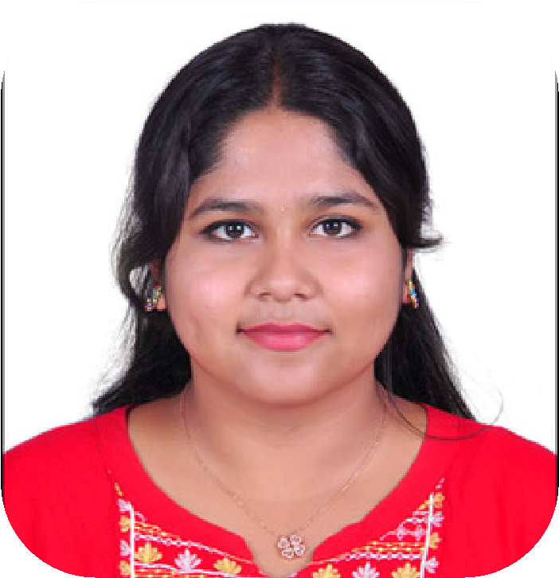

**PROFILE**

A passionate and dedicated

BTech Information Technology

student with a keen interest in

leveraging technology to solve

complex problems and drive

innovation. Equipped with a solid

foundation in computer science

and IT principles, along with

hands-on experience in various

programming languages,

software development

methodologies, and IT systems. a

drive for continuous learning and

a passion for technology

**CONTACT ME**

8667641447

727722

euit155@skcet.ac.in

C-109 Gokul Nagar,

Hosur,

Krishnagiri District,

Tamil Nadu-635109

**PROJECT**

**A WEBPAGE DEVELOPMENT ON**

**DONATION AND FUNDRAISING**

**PLATFORM**

**TECH USED :**

REACT JS

**LINK :**

[g](https://www.canva.com/design/DAGDB4X6V-s/dy7YggEOItYRW4Z-zAi5CQ/edit)

[ithub.com/SachithaGu](https://www.canva.com/design/DAGDB4X6V-s/dy7YggEOItYRW4Z-zAi5CQ/edit)

[g](https://www.canva.com/design/DAGDB4X6V-s/dy7YggEOItYRW4Z-zAi5CQ/edit)

[anat](https://www.canva.com/design/DAGDB4X6V-s/dy7YggEOItYRW4Z-zAi5CQ/edit)

[ps://](https://www.canva.com/design/DAGDB4X6V-s/dy7YggEOItYRW4Z-zAi5CQ/edit)

[htt](https://www.canva.com/design/DAGDB4X6V-s/dy7YggEOItYRW4Z-zAi5CQ/edit)

[h](https://www.canva.com/design/DAGDB4X6V-s/dy7YggEOItYRW4Z-zAi5CQ/edit)

[t](https://www.canva.com/design/DAGDB4X6V-s/dy7YggEOItYRW4Z-zAi5CQ/edit)

[an/fund-](https://www.canva.com/design/DAGDB4X6V-s/dy7YggEOItYRW4Z-zAi5CQ/edit)

[j](https://www.canva.com/design/DAGDB4X6V-s/dy7YggEOItYRW4Z-zAi5CQ/edit)

[s.](https://www.canva.com/design/DAGDB4X6V-s/dy7YggEOItYRW4Z-zAi5CQ/edit)

[g](https://www.canva.com/design/DAGDB4X6V-s/dy7YggEOItYRW4Z-zAi5CQ/edit)

[i](https://www.canva.com/design/DAGDB4X6V-s/dy7YggEOItYRW4Z-zAi5CQ/edit)

**EDUCATION**

**SISHYA SCHOOL:(TILL 10TH STD)**

percentage in 10th: 72.6%

**SRI CHITANYA:(HIGH SCHOOL)**

percentage in 12th: 76.9%

**SKILLS**

Languages and Frameworks: Java,

C++, Data structures and Algorithms ,

React js, Spring boot

Cloud Computing : AWS -S3 ,

EC2(windows, Linux and Ubuntu) ,

VPC , ELB,ECR

Data base : MySQL

Languages : English , Tamil, Hindi

**SOFT SKILLS**

Ethical Thinking

Emotional Intelligence

Leadership

Communication

Problem Solving

**SACHITHA**

**G**

**Student**

**SRI KRISHNA COLLEGE OF**

**ENGINEERING AND TECHNOLOGY**

cgpa:8.1

garduation year:2026